NAME:
Kainat Khalid

EDUCATION:
- Currently enrolled in BS English language and literature (2016-2020), International Islamic University.
- F.sc (pre-medical), Army Public School and College Westridge 3 Rawalpindi passed with A-1 grade.
- Metric (Sciences), Army Public School and College Westridge 3 Rawalpindi passed with A-1 grade.
OTHER SKILLS:
- I have decent knowledge of both science and literature.
- I can use MS word, PowerPoint and Excel diligently.
- I have good communication and presentation skills.
- I can speak both English and Urdu proficiently.
LEISURE SKILLS:
- Book reading
- Internet surfing
- Blog writing
- Story Writing
WORKS:
Some of my works are attached below.

DAMAGED

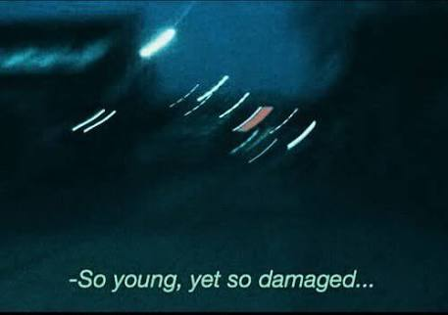
Aren’t we all afraid of the moment when the shell that we have created around us, will shatter letting loose of all the emotions and feelings that we forced ourselves not to feel…. That we forced ourselves not to think off….. Every single tear that we held back…. Every smile that we faked….. Every single “I AM OKAY” we uttered…..

Everything crashing down with a single blow….. Breaking through every atom of our body…. Not being able to withstand the after damage…. When it’s too late to go back…. When we are too broken to move forward….. Stuck in the very place from where we began.
We are all broken from the inside….. The difference is that the few of us accept our reality…..While other continues to live in denial….. Till we face the final blow….. Too overwhelming….. The damage is un-repairable.

PAIN is something we all come across at least once in our life, but only few actually experience it, while most of us are to coward to face it building a wall, too high to climb on, too thick to peak through...
We choose to fence ourselves in denial, hoping that maybe one day when we will drop our boundaries, the pain would have gone. But it NEVER does.
It lingers around the corner, accumulating, gathering every feeling of suffering, guilt, regret, anxiety, fear and everything else that can lead you towards misery……WAITING……until the wave is too strong….. too high that it forces its way through every blockage, flooding our consciousness all at once, breaking us to the point where return is impossible.
Although at times it may seem that escape is a better solution but it never is. The only possible way to overcome pain is, to FEEL it.

No matter how much it hurts, no matter how much misery it inflicts, at the end of the day its intensity will slowly fade…. Things will change….. You will be able to feel alive.
Just allow the pain to settle in before you pluck it out of your system…. Because otherwise it will continue to feed off of your guilt…. Anger…. Anxiety….. Self hate and will root itself soo deeply inside you that escape from it would become impossible.

The process is slow and torturous but it better to slowly heal then to shatter completely, once and for all.

BUTTERFLY

But you left without a goodbye like
Us, never mattered
Thinking of your adorable smile
Takes me back to those happy times,
Except that now, I only suffer from pain
Rejected, deceived and sorrow is all that I
Feel,
Loving you to the point where it’s killing me, all I want is
You to stay

ME WITHOUT YOU

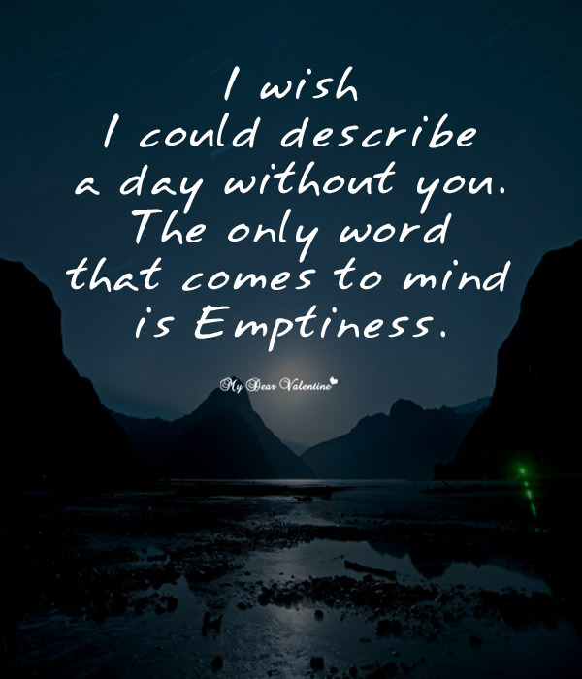
The night sky was devoid of any clouds and the sparkling moon was a huge and perfect disc entangled in the window frame. The sky was lit with twinkly stars, trying to light up the ever dark cosmos. Under this ecstatic sky, she was dragging her feet, slowly pacing through the quiet streets. Her frizzy dark hair was roughly tucked behind her ear, her large hazel eyes clouded with tears as they stream down her rosy cheeks. She knew what she did was so wrong. She was wrong to leave the love of her life behind when she needed him the most. She regretted deceiving him since she knew she won’t be able to clarify herself later. But sooner or later, it was fated to happen this way. So she left early because she wanted to see him move on with his life; to be happy again, only this time WITHOUT her.
Her steps came to halt, as her eyes met a dark ally, memories resurfacing as she remembered, that was the place where she first met him. The meeting wasn’t a happy one, as he practically saved her from getting raped, being her ‘knight in the shining armor’. A sad smile crept across her face, as she mused over her own comment. She still remembered the moonlight vaguely illuminating his features, the fury that his eyes possessed at that moment, as he beat the rapist senseless. Their next meeting was in the public library where she accidentally bumped into him, the mountain of her books crumbling down onto the floor. She could not recognize him at first. He was quite tall and had attractive features but the thing that caught her attention was his eyes. She could never forget those eyes which she had seen that night. But this time, they carry a soft, gentle look as he quickly apologized, helping her. The whole scenario may seem cliché, but that was the starting point of their eternal love story. On the coming Valentine’s Day, he confessed to her, requesting her hand in marriage which she gladly accepted.
It all felt like a dream now, as she blankly stared at the night sky; how her life was so complete and blissful. How their laughter would lit up the whole apartment, how they would hold onto each other’s warmth on a crispy, cold evening bidding farewell to the drowning sun, as it hides behind the horizon. Everything was perfect until today when she demanded him to divorce her. He was dumbfounded for a good five minutes, till reality hit him as held a heartrending expression in his eyes. His voice came out broken as he said, “I am sure this is some kind of a prank. I know you love me; we love us. If there is a problem, I am sure we can sort it out. Please don’t leave me; I love you too much to let you go”. He tried to talk her out of it, asking for a reason as to why she was doing all this but she didn’t budge. She handed him the signed papers from her bag and stormed out of the apartment.
She looked so drained and exhausted now, as she remembered today’s event. Her legs felt so heavy, her heart tightening inside her chest. She gave up and sat down on the pavement as she held her head in her hands.
Yes, she was dying and the worst part was that she couldn’t do anything about it. She was diagnosed with stage four lungs cancer with only a few months left in her lifespan. She couldn’t bring herself to tell him about it. She didn’t want to break, in front of him; she didn’t want him to see her die. She didn’t want to make him suffer each day because of her, so she left. Without a word, without giving him any explanations, she left, knowing the fact that he would hate her for what she did, but she hoped that maybe he would get over her and will actually be happy someday. Only if she knew, how wrong she was.
Days turned to weeks, as weeks turned to years. He kept searching for her everywhere like a madman but failed. Four years had passed yet he still felt lost, betrayed and empty. He hated her so much for what she did to him but couldn’t forget about her. Hating her was easier than to let her go. He busied himself with work, his health falling each and every day but he never cared. He would get up every morning with the hope that maybe today would be the day when he would get to see her. Maybe today would be the day he would catch a glimpse of her, maybe today he would accidentally bump into her. Every night sleeping with the hope that tomorrow would bring his lost love back. He wanted the answer to his question as to why did she leave him.
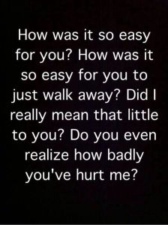

It was just another day when he visited the hospital with his friend who practically dragged him there since his asthma was getting worse and he was too lost to care about his health. As they reached the cardiology department, the doctor greeted them with a professional smile. He used to be their family doctor whom he hadn’t seen in years. The doctor’s smile faded as he saw him, when he finally spoke, “I am so sorry for your loss”. His eyebrows furrowed at the doctor’s statement as he gave him a confused look. He asked the doctor to clarify, for he couldn’t understand what the doctor meant. “I am sorry, I know your wife was diagnosed with lung cancer four years ago”, the doctor said giving a confused look to him. As soon as the doctor’s word hit his ears he felt like the core of his being shaken up. The words felt like a bomb going off, all pieces of the puzzle finally fitting into its place.
He rushed to her parent’s place, tears blurring his vision, his mind clouded with the memories of her smiling face, so full of life. As he talked to them, his head spun when they told him that it was her last wish to keep the information of her disease a secret from him. He demanded to know where she was buried. His legs couldn’t support his weight, his chest tightening, his breathing getting irregular as he made his way towards her grave. He wanted to have this moment alone with her so they left him there, giving him the privacy to let all of his feelings out. He lifted his head up, reading her name which was beautifully carved on her tombstone. Her name felt so familiar yet so foreign, carved there looking so devoid of life. He broke down, his breath got unsteady as his sobs got louder. He cried and screamed in pure agony and pain feeling like his heart was torn into million pieces. He breathed more irregularly as his asthma got severer and severer but he didn’t give any notice to it. He was feeling so much emotional pain that he became numb to the physical one. He slowly hung his head low on her grave, and never lifted it up again.

